Experiment-8

Aim : Experiment to implement any one of the clustering algorithms using Rapid Miner and Python.

Theory :
Clustering:
Clustering is an unsupervised machine learning technique used to group similar data points based on their characteristics. It helps in identifying patterns and structures within a dataset without prior labels. Common clustering algorithms include K-Means, which partitions data into k clusters, DBSCAN, which finds density-based clusters and outliers, and Hierarchical Clustering, which creates a tree-like structure of clusters. Clustering is widely used in market segmentation, anomaly detection, image analysis, and bioinformatics. The choice of clustering algorithm depends on data distribution, noise levels, and the desired cluster shapes.

K-Means Clustering:- K-means clustering is a fundamental unsupervised learning algorithm that partitions a dataset into a pre-defined number (k) of clusters. It aims to group data points based on their similarity, where similarity is typically measured by distance. The algorithm iteratively assigns data points to the nearest cluster centroid and then recalculates the centroids based on the mean of the assigned points. This process continues until the centroids stabilize, effectively minimizing the within-cluster variance. K-means is widely used due to its simplicity and efficiency, although it's sensitive to the initial centroid placement and the choice of k.

Dataset Information

seeds dataset
The Seeds datasetcontains measurements of geometrical properties for kernels belonging to three varieties of wheat: Kama, Rosa, and Canadian. The dataset comprises 210 instances, each representing a single seed, with 7 numeric attributes and no missing values. These attributes include area (kernel area in mm²), perimeter (kernel perimeter in mm), compactness (a measure of shape circularity), length of kernel (in mm), width of kernel (in mm), asymmetry coefficient (degree of asymmetry), and length of kernel groove (in mm). Originally used for classification, this dataset is well-suited for clustering due to its continuous, numeric features, which naturally group into the three wheat varieties based on physical characteristics.

Implementation :

- Python

- Loading dataset
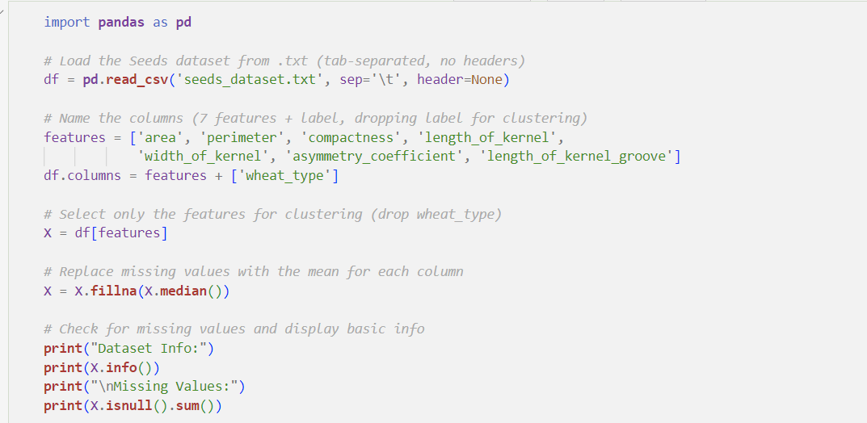
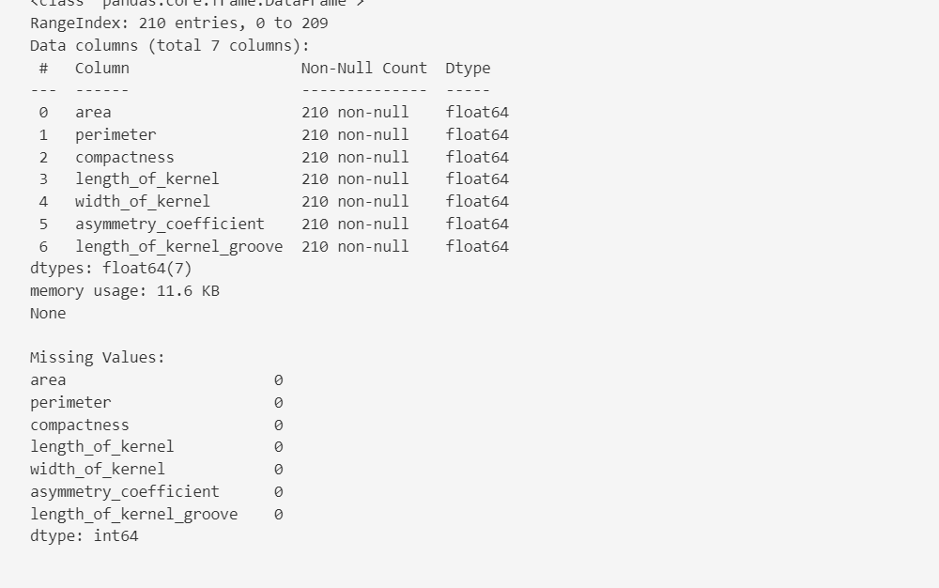

Standardizing the Data
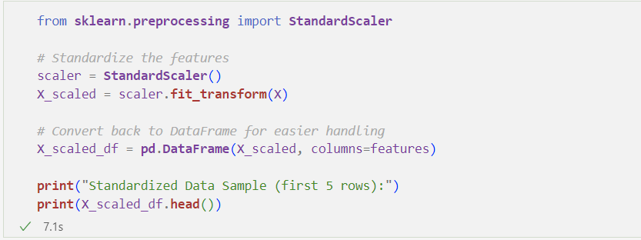

Plotting the Elbow Method Graph
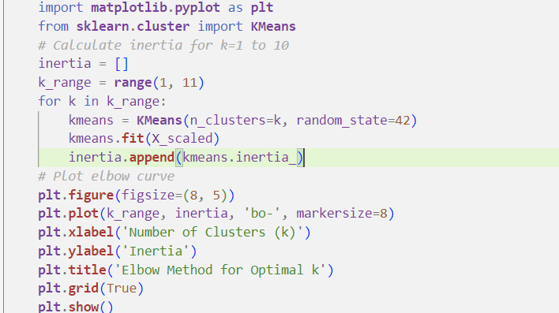
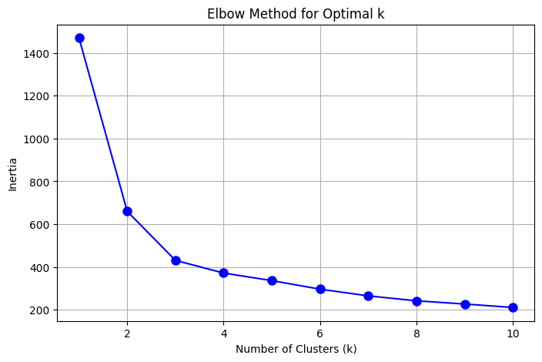

The Elbow Method helps determine the optimal number of clusters (k) by plotting the inertia (sum of squared distances from points to cluster centers) for different values of k. The point where the curve bends ("elbow") suggests the best k, balancing compact clusters and minimal inertia.

Applying K-Means Clustering (k=3)
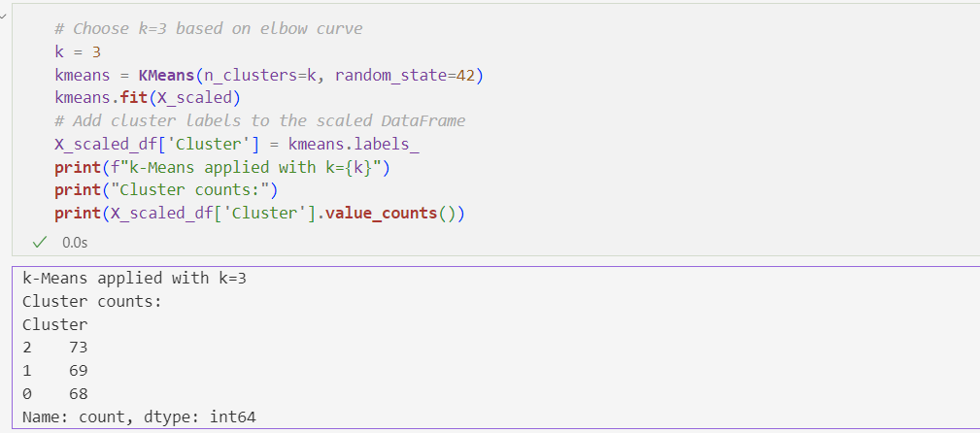

K-Means clustering is applied with k=3, as determined by the Elbow Method. The algorithm assigns each data point to one of the three clusters based on similarity. The resulting cluster labels are stored in the "Cluster" column of the dataset.

- Computing the Silhouette Score,Inertia, Davies Bouldin score

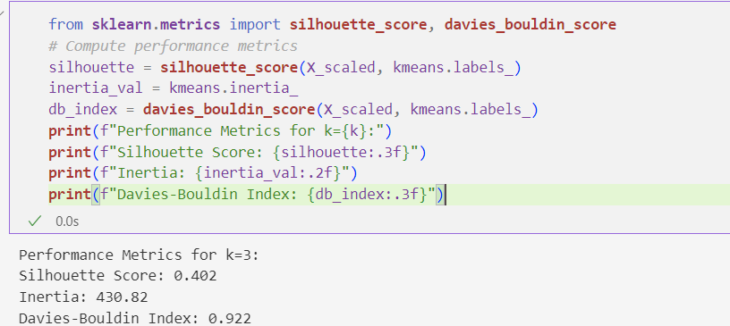

The Silhouette Score evaluates the quality of clustering by measuring how similar each data point is to its own cluster compared to other clusters. A score closer to 1 indicates well-defined clusters, while a score near 0 suggests overlapping clusters. This helps confirm if k=3 is a good choice.
So the silhouette score is depecdent on b(minimum average distance of the current cluster’s datapoint to other clusters) - a(the intra cluster distance(average)). we divide the difference by max(a,b).
For Davies-Bouldin Index:
first the formula is:
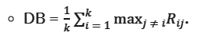
so for each cluster we first find the max of Rij ( the maximum ratio of average intracluster distances of each cluster to the distance between their centroids)
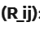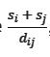 Here s is the intracluster distance. so logically if si and sj is smaller then the clusters are packed closely. and dij is the distance between their centroids. so logically for good clustering we want d to be greater. and therefore ideal cluster would be with R_ij as close to 0 as possible.

Plotting K-Means Clustering Results
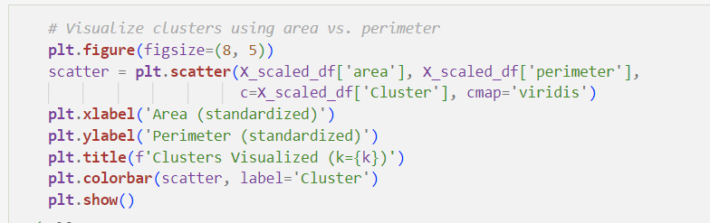
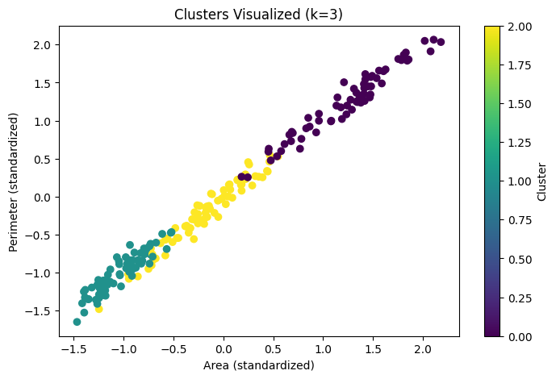
This code performs K-Means clustering on all the 7 parameters of the data, visualizing the results with a scatter plot for the dimensions of Perimeter and Area being distributed and a linear increasing of the scatter plot suggest that Perimeter adn Area are highly correlated. The plot’s compactness suggests that the chosen number of clusters (optimal_k) effectively partitions the data, highlighting potential relationships between these features and the cluster assignments.

Analyzing Cluster Characteristics
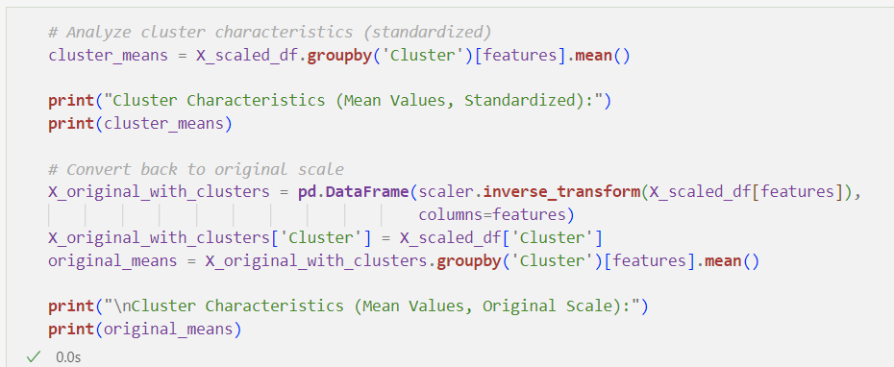
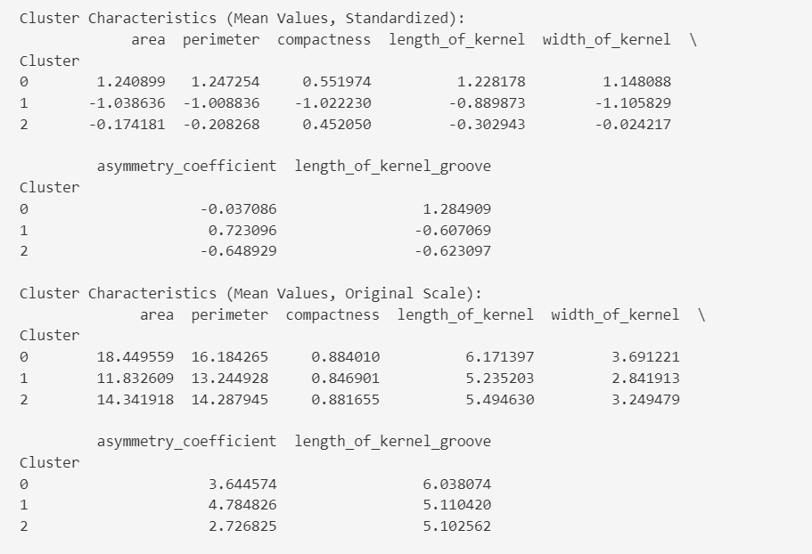

This step gives us the mean characteristics of each cluster potentially giving us the insights as to how we would identify unknown/unseen seeds.

(optional) using the format (percentage difference) that Rapid miner uses: 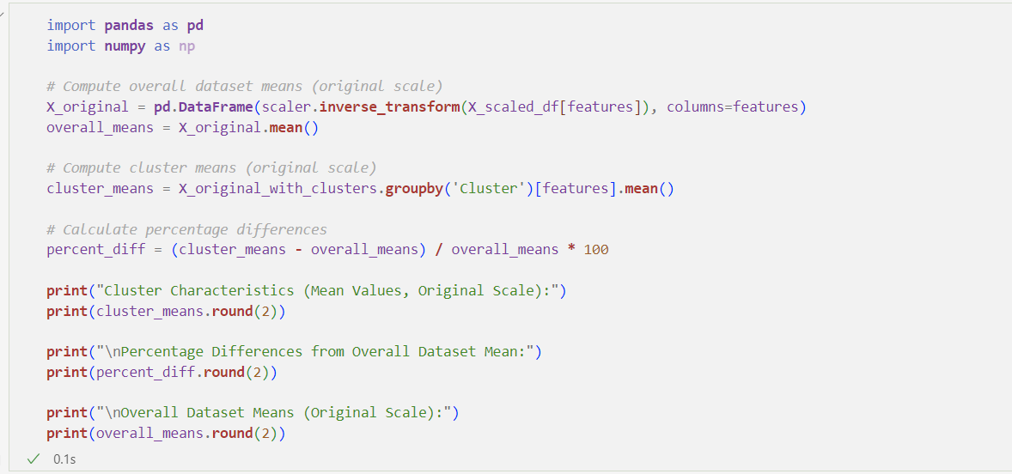
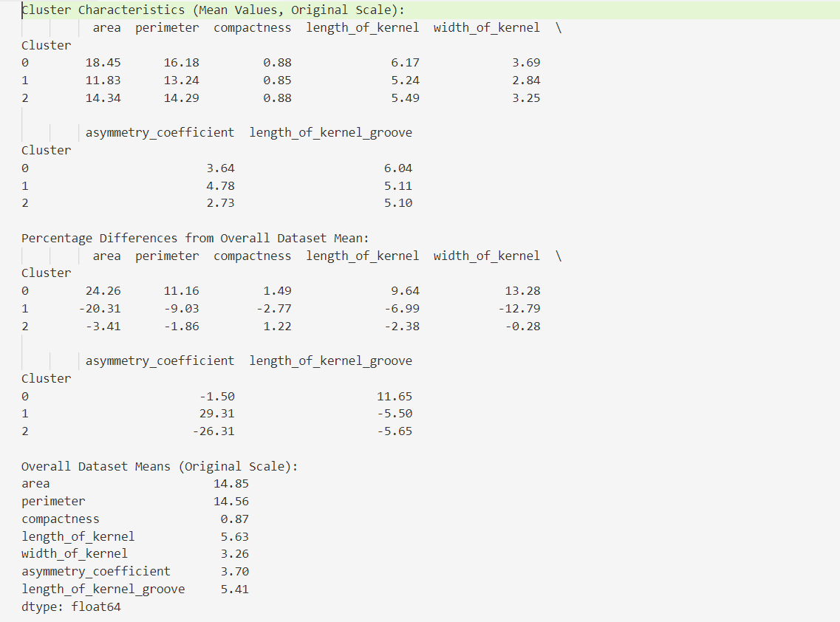

2. Rapid Miner:
- Loading the dataset
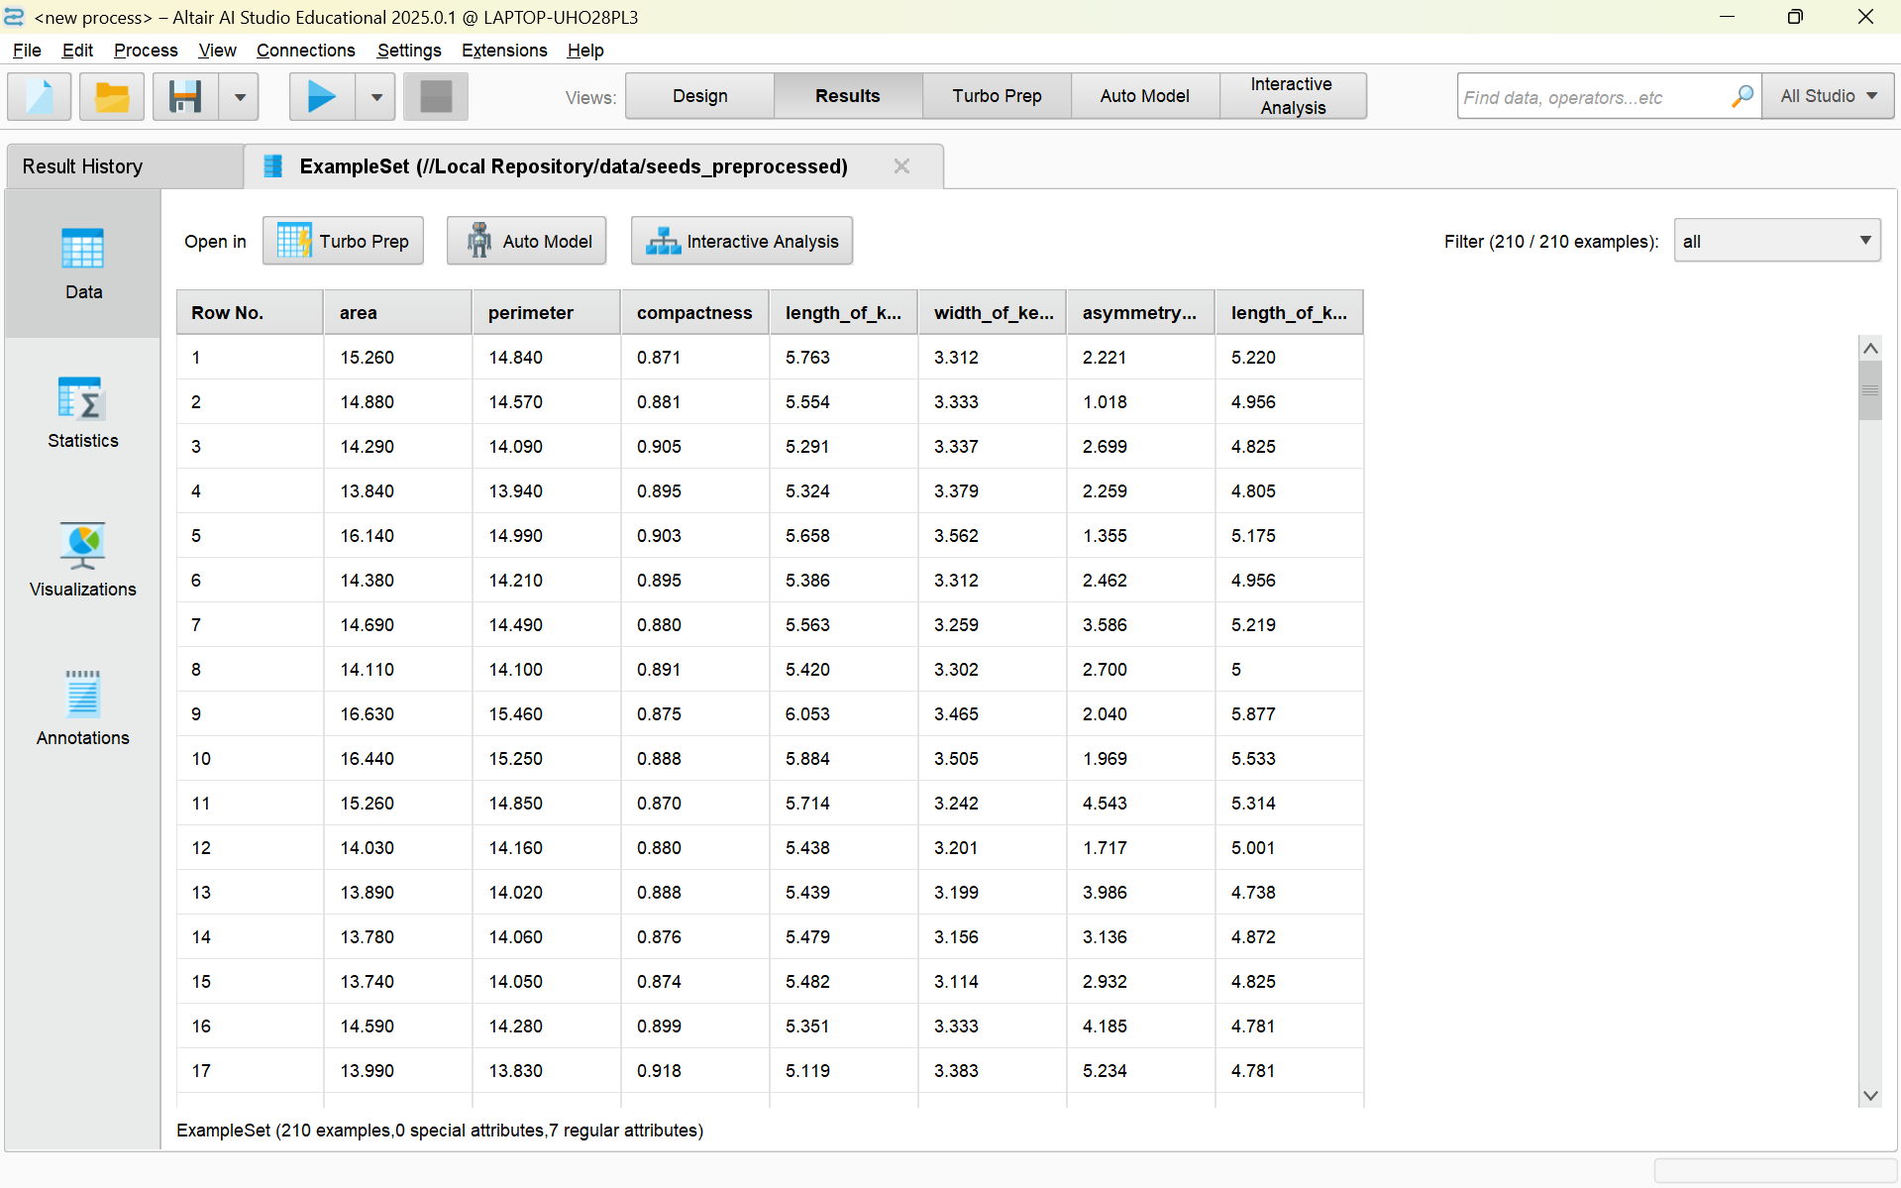

- Select Attributes for Clustering
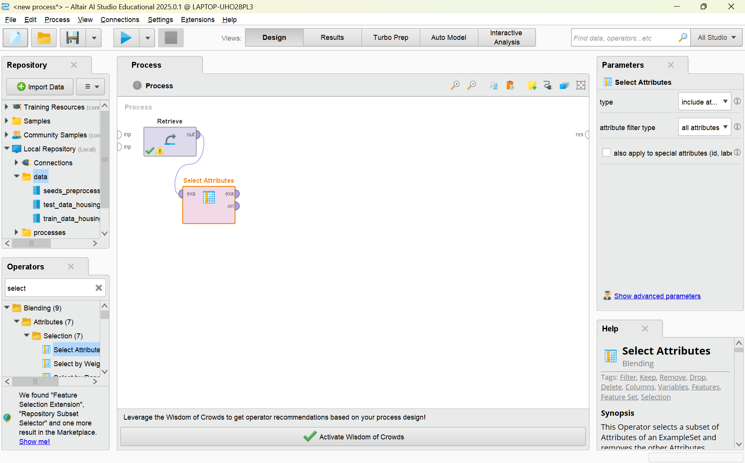
Select all the attributes.

- Replace Missing Values
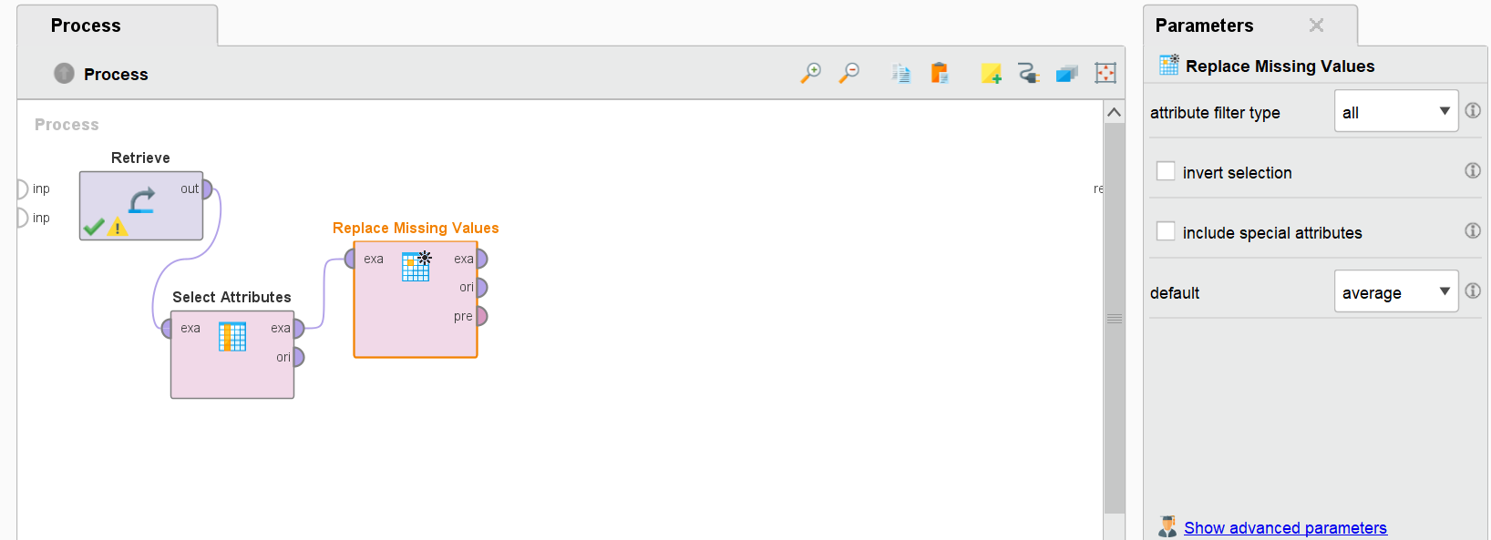
Missing values in the dataset are handled from the selected attributes, ensuring the data is clean and consistent for analysis. The "Replace Missing Values" step identifies any gaps in the selected features and replaces them with average values, as specified in the parameters panel. This approach prevents errors during model training and improves algorithm performance by maintaining data integrity. Cleaning the dataset in this way ensures reliable and accurate predictions while reducing the risk of biased or misleading results. Proper handling of missing values is a crucial preprocessing step in data analysis and machine learning workflows.

- Normalize the dataset
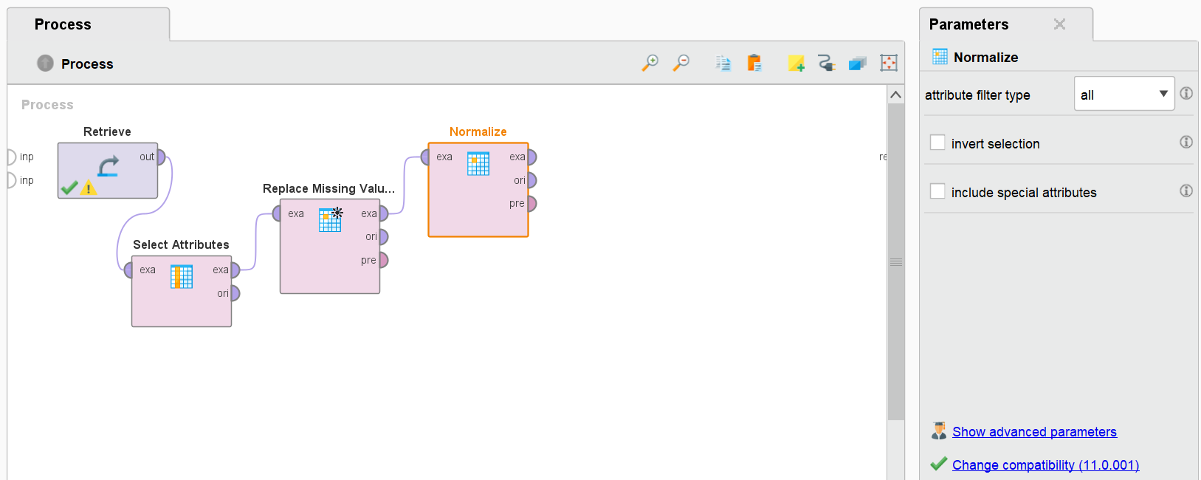
Normalization is a preprocessing technique that scales numerical features to a common range, often [0, 1] or [-1, 1], ensuring consistent and comparable data. It’s crucial for distance-based algorithms and improves the performance of gradient-based models by preventing features with larger magnitudes from dominating. Common methods include Z-Score Normalization.
Proper normalization enhances model accuracy and stability.

- K-Means Clustering
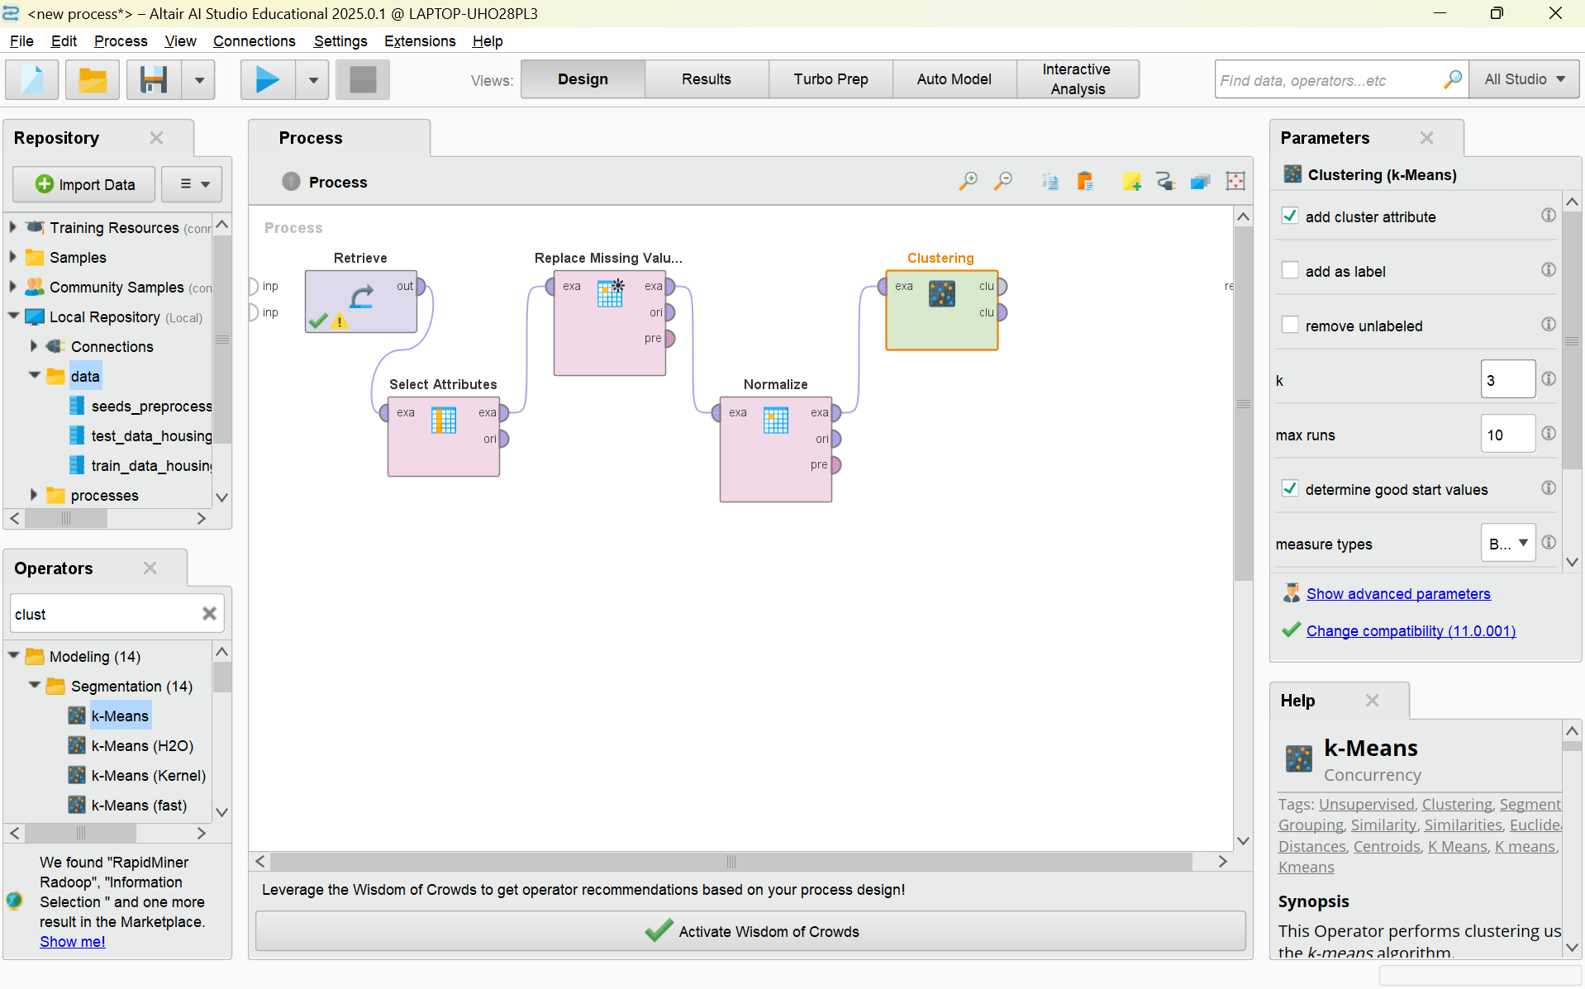
Applying K-means clustering with k=3 as identified by the elbow method in the python implementation.

- Cluster Model Visualizer
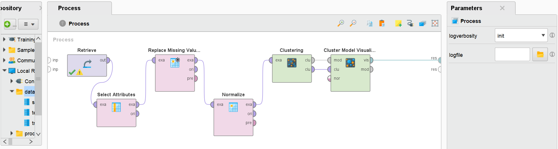
The Cluster Model Visualizer provides a graphical representation of the K-means clustering results. It displays data points colored according to their assigned clusters, facilitating visual analysis of the clustering's effectiveness. Users can examine the distribution and separation of clusters, gaining insights into the underlying data structure and the algorithm's performance.

- Details About Clusters
click on the start execution.
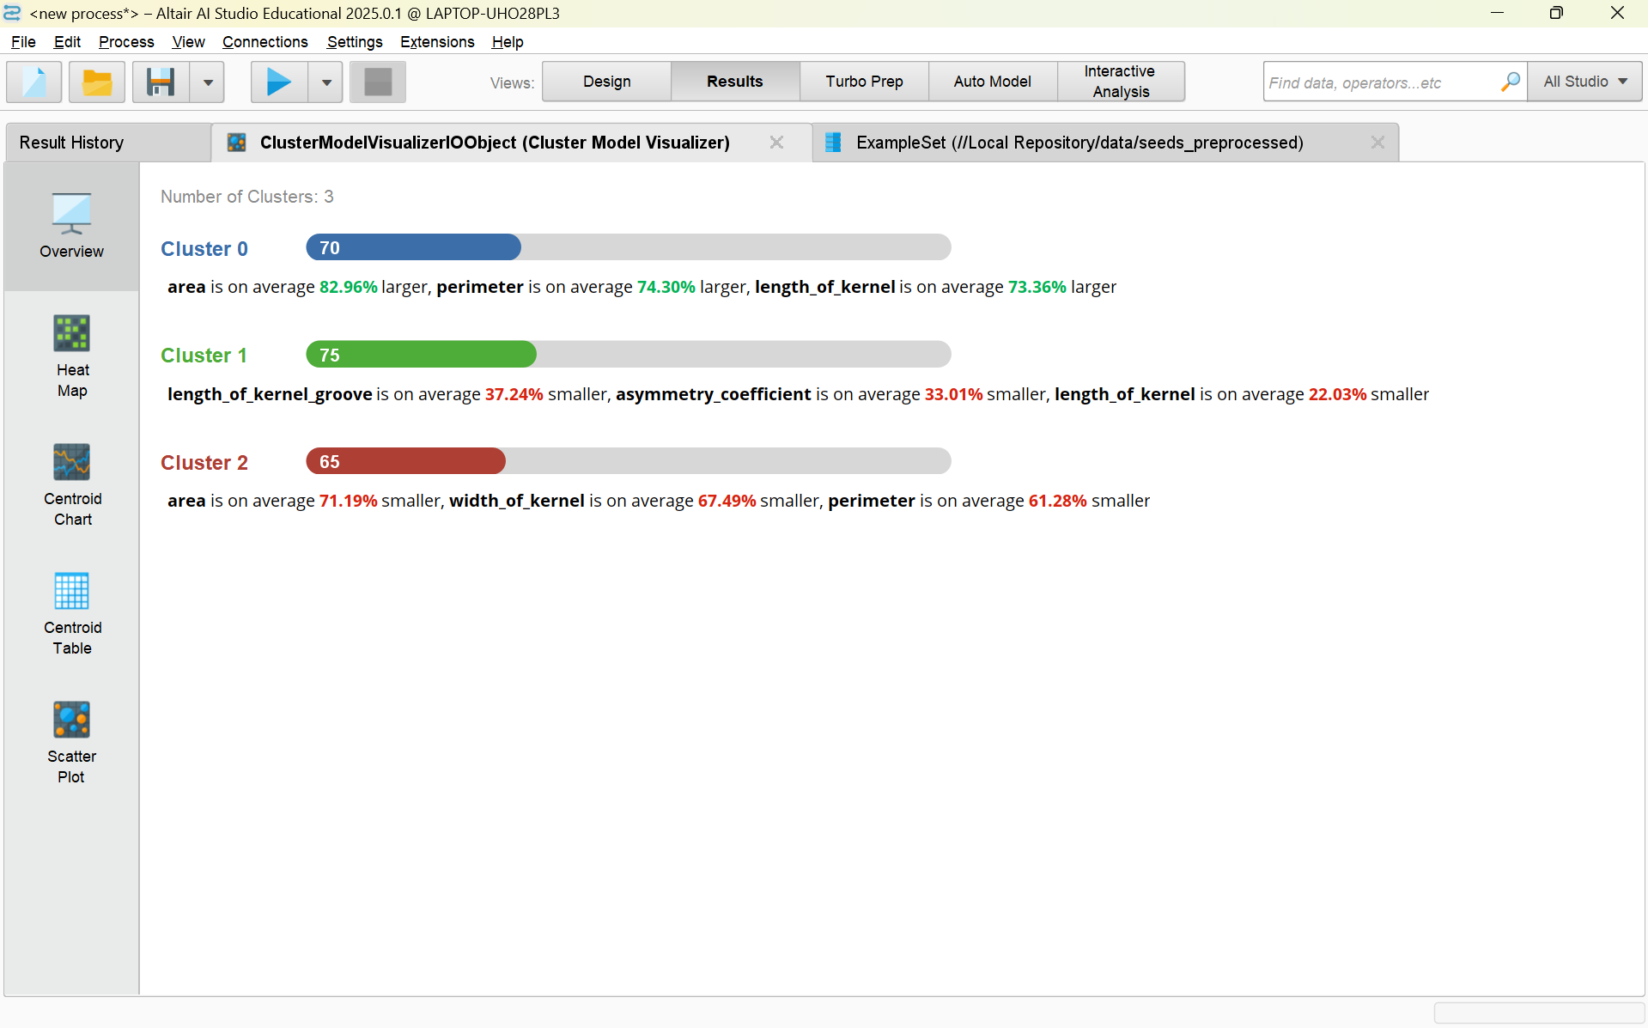
This output summarizes the results of a clustering analysis performed on a dataset. Three clusters (Cluster 0, Cluster 1, and Cluster 2) have been identified, and key characteristics of each cluster are described:
- Cluster 0: Contains 70 elements, with attributes like area, perimeter, and length of kernel significantly larger on average.
- Cluster 1: Contains 75 elements, where features such as length of kernel groove, asymmetry coefficient, and length of kernel are noticeably smaller on average.
- Cluster 2: Contains 65 elements, with attributes like area, width of kernel, and perimeter being considerably smaller on average.
The mean of each cluster is compared with the overall mean for this output.

- Scatter Plot
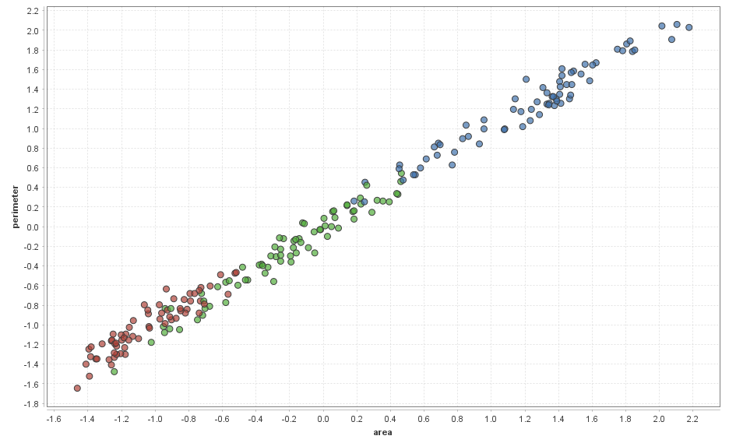

The scatter plot, within the context of the seeds dataset, shows the relationship between area and perimeter, which are two key features used for clustering types of seeds.
The distinct clusters suggest that these seed types (Canadian, Rosa and Kama) differ in physical attributes like area and perimeter, making clustering a suitable method for classification. The positive correlation reflects that seeds with a larger area tend to have a larger perimeter, consistent with the geometric properties of objects.

Comparison of Rapid Miner and Python
Feature | Python | RapidMiner
Customisation | High Flexibility . | Low (GUI based , pre-set options).
Ease of Use | Requires coding knowledge. | Easier for beginners.
Evaluation Metrics | Silhouette score used for validation. | No explicit evaluation metric.
VIsualisation | More customizable with Matplotlib/Seaborn. | Built in visualisation tools.
Execution Time | Faster with optimized code. | Slightly slower due to GUI overhead.

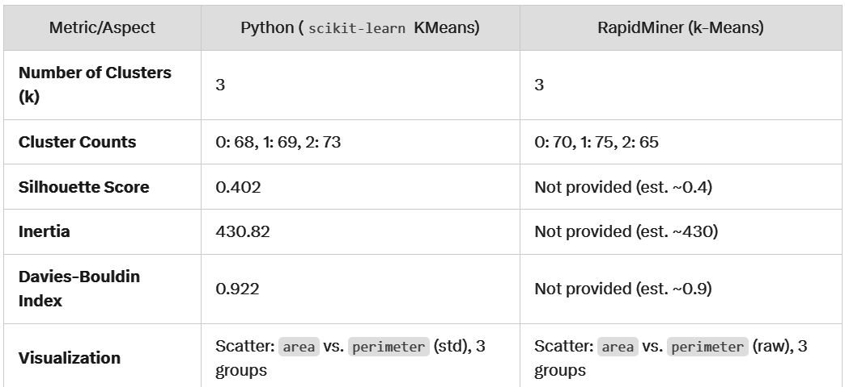

Conclusion:-
The K-means clustering algorithm was successfully implemented using both Python and Rapid Miner to analyze the seeds dataset. The Python implementation utilized libraries like scikit-learn for algorithmic application and Matplotlib/Seaborn for visualization, demonstrating a code-centric approach. In contrast, Rapid Miner provided a GUI-based workflow, simplifying the process through operators for data handling and visualization. Both implementations effectively partitioned the data into three clusters, revealing an direct correlation between area and perimeter (while visualising the plot in 2d)
While Python offered flexibility and customization through coding, Rapid Miner streamlined the clustering process with its visual interface. Ultimately, both tools provided valuable insights into the wine dataset, highlighting distinct groupings based on the selected features.

